CORRADO RUSTICI

RENOWNED ITALIAN GUITARIST RELEASES NEW SOLO ALBUM

‘INTERFULGENT’ – AVAILABLE FROM FEBRUARY 26TH

Corrado Rustici, the renowned guitarist and producer, has released a brand new instrumental solo album entitled Interfulgent. The album is available from Friday February 26th and a video for one of its tracks “Night of the Jackal” can be seen below.

A founding member of celebrated 70’s prog act Cervello, as well as the jazz-rock group Nova alongside his brother Danilo, Corrado’s status within the world of progressive music is legendary. He has performed and recorded with the likes of Phil Collins, Allan Holdsworth, Herbie Hancock and Miles Davis through his illustrious 40 year career, which has also seen him become one of Italy’s most successful producers. Working with international artists as well as stars from his home country, Corrado has been involved with some of the biggest albums of recent years, creating a hugely impressive body of work.

Having released several solo albums throughout his career, his latest work Interfulgent seeks to place his chosen instrument and voice, the electric guitar, into a more contemporary musical context. Characterised by wholly unique guitar sounds created from his own range of signature pedals and effects, Corrado’s guitar work is incredibly expressive, original, and liberating for what the instrument is truly capable of.

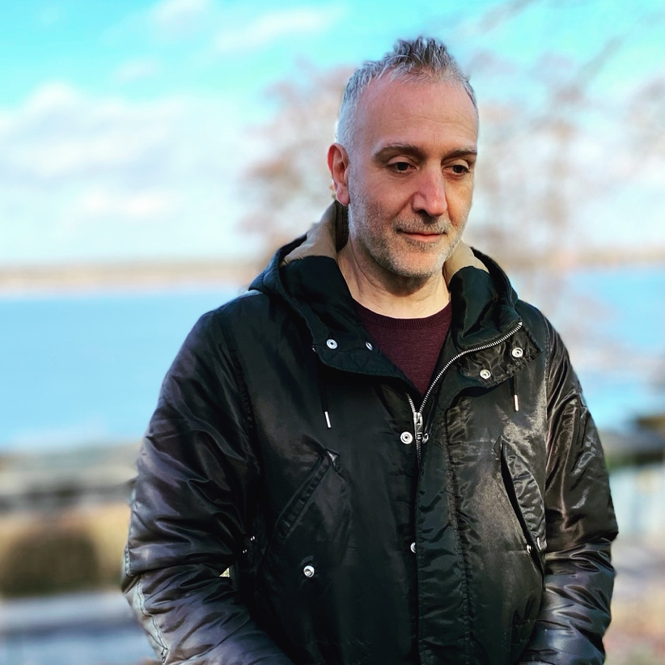

WATCH THE “NIGHT OF THE JACKAL” VIDEO HERE

Corrado has dubbed this as a “transmodern” project, where all the melodies and rhythms were constructed with contemporary electronic sounds. Together with influences from fusion, progressive and classical music, this creates some wildly evocative musical landscapes. He describes it as “an artistic interpretation of a profound desire to transcend the socio-cultural darkness that surrounds us with the help of new concepts, metaphorically represented on the cover by a luminous object... a harbinger of better times ahead.”

All of the music on the album was performed by Corrado, with some additional contributions from keyboardist Alex Argento (Icefish). “Alex contributed with some great ideas” adds Corrado, “even though it was the first time that we worked together it soon became apparent that we both shared a lot of human and artistic common grounds.”

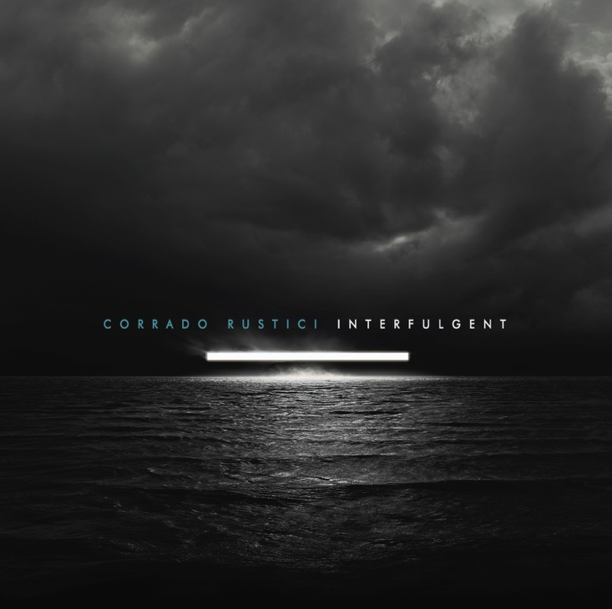
Interfulgent Track list:

- Halo Drive
- Night of the Jackal
- The man from Yorkshire
- Black Swan
- Anna
- Interfulgent
- Khetwadi Lane
- ZuZu Blues
- The waters of Enceladus
- G. on a sunny day
Interfulgent is now available to buy as a limited edition CD (signed by Corrado) or digital album from Corrado’s official website and his Bandcamp store:

www.corradorustici.com

corradorustici-official.bandcamp.com

Contact Corrado Rustici

PR/Interview enquiries: ryan@rjprmusic.com

Follow Corrado Rustici

Website: www.corradorustici.com
Bandcamp: corradorustici-official.bandcamp.com
Facebook: www.facebook.com/corrado.rustici
Instagram: www.instagram.com/corradorustici
YouTube: www.youtube.com/channel/UCLZL3IT55-8SHvjXeTxf4Kw
Electronic Press Kit: https://rjprmusic.com/corrado-rustici-press-kit

