###
THE ARISTOCRATS WITH PRIMUZ CHAMBER ORCHESTRA
AVAILABLE NOW!
**north america tour starts on july 1**

The renowned rock/fusion power trio The Aristocrats (guitarist Guthrie Govan, bassist Bryan Beller and drummer Marco Minnemann) have released The Aristocrats With Primuz Chamber Orchestra. Their first orchestral collaboration reveals a lush and lavish musical reimagination and sonic reinvention of compositions from throughout the band’s storied catalog. All order links can be found at https://linktr.ee/AristocratsBand.

The band also dropped their third video for the album, featuring rare Aristocrats band footage and Primuz Chamber Orchestra tracking shots.

Check out the video for “Stupid 7” here: https://youtu.be/OWLBbmxpuxk

Two additional videos have been released as well.

Check out “Jack’s Back” here: https://youtu.be/69JyxJjJK2k

Check out “The Ballad Of Bonnie And Clyde” here: https://youtu.be/mmnUaMocySc

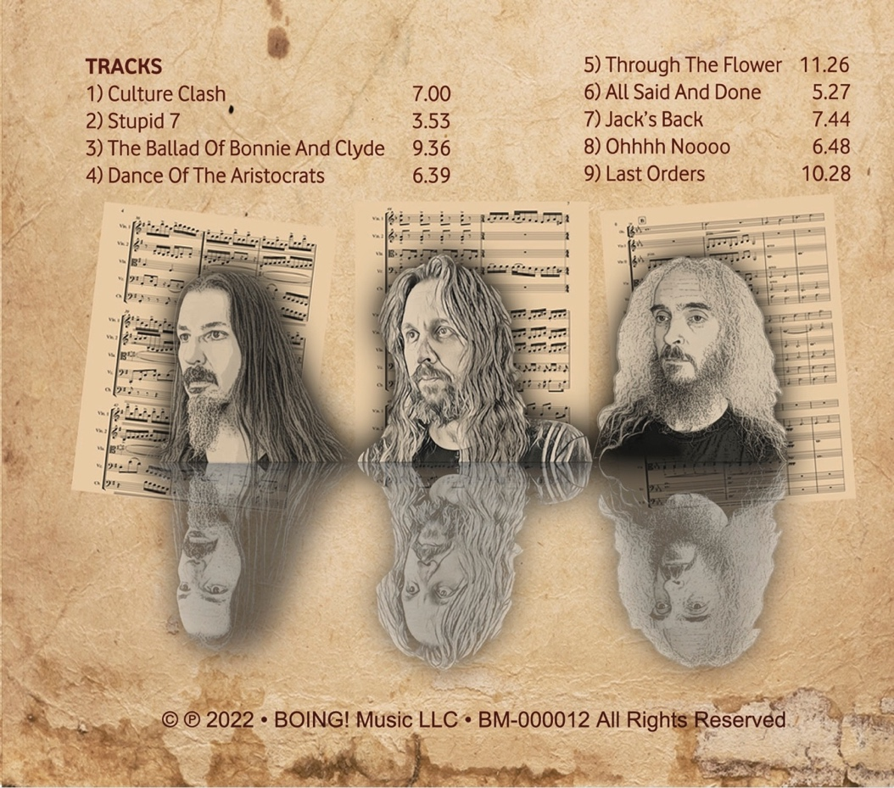

Track Listing
- Culture Clash
- Stupid 7
- The Ballad Of Bonnie And Clyde
- Dance Of The Aristocrats
- Through The Flower
- All Said And Done
- Jack’s Back
- Ohhhh Noooo
- Last Orders
The Aristocrats With Primuz Chamber Orchestra drops just weeks before the start of the band’s first tour in over two years – the 10-week, 50-date North American DEFROST tour, on which new material from the band will be debuted. All dates and ticket links are available at https://the-aristocrats-band.com/shows.

The Aristocrats DEFROST North American Tour
DATE | VENUE | CITY, STATE
July 1, 2022 | Alvas Showroom | San Pedro, CA
July 2, 2022 | Alvas Showroom | San Pedro, CA
July 3, 2022 | Ramona Main Stage | Ramona (San Diego), CA
July 6, 2022 | The Mob | Mexicali, MX
July 7, 2022 | Rhythm Room | Phoenix, AZ
July 8, 2022 | Club Congress | Tucson, AZ
July 9, 2022 | Rockhouse Bar & Grill | El Paso, TX
July 10, 2022 | Launchpad | Albuquerque, NM
July 13, 2022 | The Parish | Austin, TX
July 14, 2022 | Guitar Sanctuary | McKinney, TX
July 15, 2022 | Guitar Sanctuary | McKinney, TX
July 16, 2022 | Scout Bar | Houston, TX
July 18, 2022 | Southport Music Hall | New Orleans, LA
July 20, 2022 | Jack Rabbits | Jacksonville, FL
July 21, 2022 | Will’s Pub | Orlando, FL
July 22, 2022 | Boca Black Box | Boca Raton, FL
July 23, 2022 | The Brass Mug | Tampa, FL
July 26, 2022 | Aisle 5 | Atlanta, GA
July 27, 2022 | City Winery | Nashville, TN
July 28, 2022 | Isis Music Hall | Asheville, NC
July 29, 2022 | Neighborhood Theatre | Charlotte, NC
July 30, 2022 | The Pour House | Raleigh, NC
August 1, 2022 | Rams Head On Stage | Annapolis, MD
August 2, 2022 | Sellersville Theater | Sellersville, PA
August 3, 2022 | Gramercy Theatre | New York City, NY
August 9, 2022 | The Middle East | Boston, MA
August 11, 2022 | Imperial Bell | Quebec City, QC
August 12, 2022 | Café Campus | Montreal, QC
August 13, 2022 | Café Campus | Montreal, QC
August 14, 2022 | Opera House | Toronto, ON
August 16, 2022 | This Is Red | Pittsburgh, PA
August 17, 2022 | Beachland Ballroom | Cleveland, OH
August 18, 2022 | The Magic Bag | Detroit, MI
August 19, 2022 | Irving Theater | Indianapolis, IN
August 20, 2022 | Reggie’s | Chicago, IL
August 22, 2022 | Amsterdam Bar And Hall | St, Paul, MN
August 23, 2022 | xBk Live | Des Moines, IA
August 24, 2022 | RecordBar | Kansas City, MO
August 26, 2022 | The Black Sheep | Colorado Springs, CO
August 27, 2022 | Marquis Theater | Denver, CO
August 28, 2022 | Mesa Theater | Grand Junction, CO
August 29, 2022 | Urban Lounge | Salt Lake City, UT
August 30, 2022 | The Shredder | Boise, ID
September 1, 2022 | Rickshaw Theatre | Vancouver, BC
September 2, 2022 | Neumos | Seattle, WA
September 3, 2022 | Star Theater | Portland, OR
September 4, 2022 | Sessions Music Hall | Eugene, OR
September 6, 2022 | Harlow’s | Sacramento, CA
September 8, 2022 | 1720 | Los Angeles, CA
September 9, 2022 | Great American Music Hall | San Francisco, CA

For more information on The Aristocrats, please visit:
- Website: http://the-aristocrats-band.com/
- Facebook: https://www.facebook.com/aristocratsband
- Twitter: https://twitter.com/acratsband
- Instagram: https://instagram.com/thearistocratsband/
For press inquiries and additional information such as photographs, please contact Ryan Jenkins of RJPR at ryan@rjprmusic.com.

# # #

